Sistemas Informáticos (Computer Systems)  
Unit 09. Backups

short line

Authors: Sergi García, Alfredo Oltra

Updated December 2023

Licencia

**Reconocimiento - No comercial - CompartirIgual** (BY-NC-SA): No se permite un uso comercial de la obra original ni de las posibles obras derivadas, la distribución de las cuales se ha de hacer con una licencia igual a la que regula la obra original.

Nomenclatura

A lo largo de este tema se utilizarán diferentes símbolos para distinguir elementos importantes dentro del contenido. Estos símbolos son:

📖 **Important**

❕ **Attention**

💬 **Interesting**

**INDEX**

**1. Backups 2**

**1.1 Backup policy 3**

**1.2 Kinds of backups 3**

**1.2.1 Full backups 3**

**1.2.2 Incremental Backups 3**

**1.2.3 Differential backups 3**

**2. Hardware for backups 4**

**2.1 Magnetic Tapes 4**

**2.2 RAID systems 5**

**2.2.1 JBOD 5**

**2.2.2 RAID 0 5**

**2.2.3 RAID 1 6**

**2.2.4 RAID 4 6**

**2.2.5 RAID 5 7**

**2.2.6 RAID 0+1 or RAID 01 7**

**2.2.7 RAID 1+0 or RAID 10 8**

**2.2.8 RAID 50 8**

**2.2.9 Other kind of RAID (RAID 6 and RAID 60) 8**

**2.3 Comparison table between RAID systems 8**

**3. Bibliography 9**

Unit 09. Backups

# Backups

The loss of data in any type of business is undoubtedly one of the biggest problems that today a company can face today. For this reason, it is very important to have a good backup policy that allows the recovery of the data in the least possible time

📖 **Important** Problems can come for different reasons: deterioration, catastrophes (natural or man-made) and other problems.

In a simple way, we could say that to make a backup is to copy the information in a support other than the habitual one, but really, making a backup correctly is something that must be analyzed in detail.

## Backup policy

The name of backup policy includes a series of rules that must be followed for optimizing the creation and recovery of copies.

For instance, some rules that can be included in a backup policy can be (based on <https://loogic.com/politicas-de-copias-de-seguridad-no-pierdas-tiempo-ni-dinero/>):

* Make **daily** backups of information that is updated frequently, and of high value for your business.
* Make **weekly** copies of less sensitive information, but still contains a certain value for the company, in addition to the usual daily information.
* To retain at least during one week the daily copy, and at least one month the weekly copy. You can rotate the media (backup tape, re-writable DVD/BD, hard disk, etc.) but retain information of a certain time.
* Keep a copy of each month for at least one year.
* Keep an annual copy of the information forever.
* Perform a backup recovery simulation from time to time.
* The medium where backups are placed must be different from the place where they have been made.

## Kinds of backups

### Full backups

The most basic and complete type of backup operation is the full backup. It consists of making a copy of **all** the data. The problem is that the recording time and the space that is necessary are higher than the rest of kinds but, on the other hand, its recovery time is faster since the data is accessed directly without needing previous copies.

It is usual for backup operations to combine full backup with incremental or differential backups.

### Incremental Backups

An incremental backup operation **only copies the data that has changed since the last backup operation** of any type. The time and date of the file is usually used, comparing it with the time and date of the last backup.

Its time of recording and the space that they require are the smallest, but by contrast, the recovery is the slowest, since to obtain a current file it is necessary to go recovering back all the copies until the last complete

### Differential backups

It is an operation similar to incremental backup, but in this case, each time it is run, it will continue to copy **all data that has changed since the previous full backup**.

It is an intermediate solution. Furthermore, it stores more data than an incremental backup, although usually much less than a full backup. In addition, performing differential backups requires more space and time than incremental backups, but less than full backups.

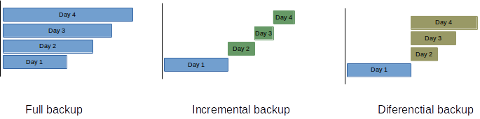

*Figure 1 - Comparative table of Kinds of backups.*

# Hardware for backups

Besides the hard drives and optical media (CD, DVD, Blu-ray), there are other storage systems more focused on creating and restoring large volume backups or in increasing of reliability of the data. Within these systems, we mainly have:

* **Magnetic tapes.** Similar to old cassette tapes. They are slow (the access time is about seconds) and sequential access, but large storage capacity (in many cases, to increase the capacity of the tapes the data are compressed). Its main task is the storage of large amounts of data
* **Hard drives mounted in RAID**. Its aim is to increase the reliability of the stored data.

## Magnetic Tapes

A tape is a type of storage device that is used for information backup and archiving. It consists of a long strip of magnetic tape, on which data can be recorded and stored. Tapes are typically used in combination with a tape drive, which reads and writes data to the tape.

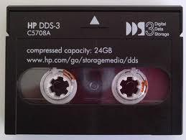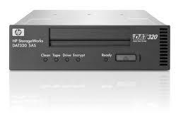

*Figure 2 - Magnetic data recording tape and reader / recorder device*

One advantage of tapes is their long lifespan. They can last for decades if they are stored properly and not subjected to physical damage. Tapes are also relatively inexpensive compared to other types of backup storage, such as hard drives or cloud storage.

However, tapes have several disadvantages as well. They are relatively slow to access, as data must be read sequentially from the start of the tape to the desired location. Tapes are also prone to physical damage, as they can be easily damaged by bending, tearing, or exposure to heat or moisture. Finally, tapes require specialized equipment, such as a tape drive, to read and write data, which can add to the cost of using them for backup.

There are other types of backup storage available that have different advantages and disadvantages. For example, hard drives are faster to access than tapes, but they are more prone to failure and have a shorter lifespan. Cloud storage is convenient and easily accessible, but it can be expensive and may not be suitable for storing large amounts of data.

## RAID systems

RAID systems are one of the most common and standardized methods for increasing the performance and/or reliability of disk storage systems. Its acronyms mean ***Redundant Array of Inexpensive Disks*.**

The best way to understand it is to analyze its own acronyms:

* **Disk array:** This is a structure made up of several disks (at least two). The more discs you have, the more reliability.
* **Redundant**: information is stored repeated, either in whole or in part.
* **Economical**: The performance of a RAID implemented with mid-range disks can be higher than a high-end disc.

The disks used can be of any type of interface, IDE/PATA, SATA or SCSI, although historically it has been the last one that was implemented with more assiduity. Today, with the improvement in performance and price of SATA hard drives, it is becoming very common to see this interface.

RAID systems can be deployed in two ways:

* **Through software:** It is a slower system, which also involves working load to the processor. The great advantage is that it can be implemented in any system that contains at least two connectors for hard disks, and is therefore cheaper.
* **Through hardware:** It is much more optimized than the previous method since all the work is done by a specialized element called RAID controller.

💬 **Interesting:** Until recently, RAID controllers cost a lot of money, but currently most SATA disk controllers integrated some RAID (level) board so that the user only needs the disks and set up.

RAID systems are classified into the called **RAID levels**. Each of these levels require a number of resources (hard drives) and offer a number of reliability and/or performance improvements.

Detailed information about RAID system can be found in <https://es.wikipedia.org/wiki/RAID>.

### JBOD

Although this level is not in itself a RAID level (they do not increase nor reliability nor performance) many RAID controllers implement it because it is very simple.

It simply consists of the logical union of several hard disks, so that when one is filled, the system begins to use the next one, but without the user noticing anything.

It is useful when there are small hard disks that by themselves are not very useful but that can solve problems of space (for example if we are creating video)



*Figure 3 - JBOD schema*

An example of operation is shown in the figure. When the D0 disk is full, the next file (D) is automatically saved to D1 without the user noticing anything. The same thing happens when filling D1; The file F is automatically recorded in D2.

### RAID 0

The purpose of RAID 0 is to increase performance because it has no redundancy. In fact, a failure of one of the RAID 0 disks involves **losing all the information**. To implement this level, you need at least two hard disks. The system divides the information by blocks, distributing the files by the N hard disks configured at the same time.

The main advantage of RAID 0 is an improvement in performance since it can be read or written at once on multiple disks, being able, theoretically, to get up to twice the speed with two identical hard disks or even more if the number of disks is greater, provided that when they are connected so that the access can be simultaneous

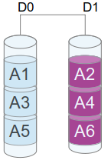

*Figure 4 - RAID 0 schema*

An example of operation is shown in the figure. A file A is divided into blocks that are written to different hard disks. Obviously, if a disk fails, the blocks of that disk are irrecoverable and therefore so is the file.

❕ **Attention:** This system should only be used where the integrity of the information is not critical.

### RAID 1

Raid 1, also, called mirroring. It is a system in which there is total redundancy, since it is made a mirror copy of all the stored information. Its fundamental objective is to increase the reliability, but also the performance in reading, since it is possible to do it reading of two disks at the same time (not the one of writing, that stays equal).

In case of error the recovery time is 0, since while disconnected one of the disks and connecting another it is possible to use the existing copy in the "mirror" (although it is advisable not to do it for safety). Once the new disk is connected, there is a copy time in which the mirror data is copied to the new disk.

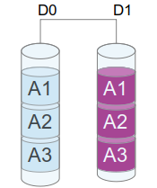

*Figure 5 - RAID 1 schema*

An example of operation is shown in the figure. A file copies its blocks on both disk 0 and disk 1.

❕ **Attention:** If you have minimally important data, this RAID mode is very interesting, and we could say almost obligatory.

### RAID 4

The RAID 4 system divides the files into blocks the size of sectors of the hard disk (usually 512 bytes, but it can be different depending on system). This already brings performance advantages (and the more hard drives the better), but it also includes an error correction system (an ECC, for example). That occupies one of the disks. Therefore, at least 3 discs are required.

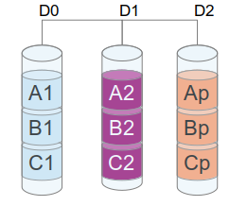

*Figure 6 - RAID 4 schema*

An example of operation is shown in the figure. File A distributes its blocks between the D0 and D1 disks, and on the D2 disk it stores the generated parity of the file. In case of failure of one of the disk, the system is able to "survive", but not so to the failure of two of them.

### RAID 5

It is the most used in professional systems. It is very similar to RAID 4, but with the parity information distributed by each of the data blocks, always in a different disk to those that the dataset are stored. This means a slightly better performance than RAID 4 in writing.

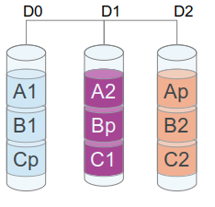

*Figure 7 - RAID 5 schema*

A RAID 5 system survives the failure of one of the disks, but not the failure of two, since the parity block can mathematically combine and obtain one of the blocks.

### RAID 0+1 or RAID 01

It is a nested RAID system, so each RAID system is viewed as another RAID system as a single hard disk. In this case, the system of disks in RAID 0 joined by RAID 1.

What is achieved is a performance as high as RAID 0, but with the fault tolerance offered by RAID 1. At least 4 disks are required and is supported by almost all controllers.

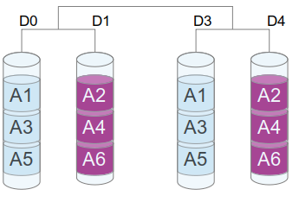

*Figure 8 - RAID 01 schema*

If a RAID 0 disk fails, nothing happens, but the data will be lost if any of the other RAID 0's disk fails.

### RAID 1+0 or RAID 10

Do not confuse with RAID 01. It is used more habitually than the previous one. It is a set of several RAID 1 disks attached through RAID 0. Furthermore, it is a bit more fault-tolerant, as it supports the failure of multiple disks whenever they occur in different RAID 1

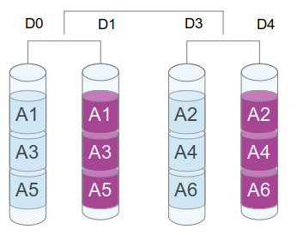

*Figure 9 - RAID 10 schema*

### RAID 50

It is very similar to RAID 10, but joining several RAID 5 instead of RAID 1. By using parity instead of a mirror copy, you gain more space and with sufficient number of hard disks, fault tolerance may be better.

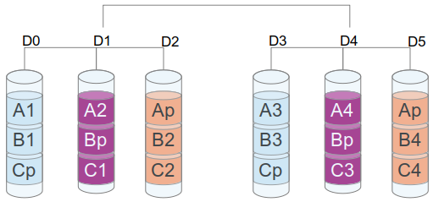

*Figure 10 - RAID 50 schema*

### Other kind of RAID (RAID 6 and RAID 60)

There are other kinds of RAID systems like RAID 6 and RAID 60. They are similar to RAID 5 and 50, but the main difference is that parity blocks are mirrored in order to obtain better security in case of losing disk. For this reason, to set a RAID 6 you need at least 4 disks (3 disks in RAID 5) or for a RAID 60 you need 8 disk (6 disk in RAID 50).

You can obtain more information in <https://es.wikipedia.org/wiki/RAID>

## Comparison table between RAID systems

| **RAID Type** | **Description** | **Fault Tolerance** | **Capacity Utilization** | **Performance** | **Minimum number of drives** |
| --- | --- | --- | --- | --- | --- |
| RAID 0 | Striping - Increased performance and capacity, but no data redundancy | None | 100% | High | 2 |
| RAID 1 | Mirroring - Data redundancy by copying data to multiple disks | 1 disk | 50% | Slowest disk | 2 |
| RAID 5 | Striping with parity - Data redundancy by distributing parity information across multiple disks | 1 disk | (N-1)/N | High | 3 |
| RAID 6 | Striping with dual parity - Increased data redundancy by storing 2 sets of parity information | 2 disks | (N-2)/N | High | 4 |
| RAID 01 | Mirrored Striping - A combination of RAID 0 and RAID 1, RAID 01 combines mirroring and striping to offer both increased performance and data redundancy. | 1 drive in each mirrored set | 50% of total drives | High | 4 |
| RAID 10 | Mirrored Striping - Both increased performance and data redundancy | 1 drive in each mirrored set | 50% of total drives | High | 4 |
| RAID 50 | Striped RAID 5 - provides higher data protection and capacity compare to RAID 5 alone | 1 drive in each RAID 5 set | (N-1)/N * M (M = Number of RAID 5 sets) | High | 6 |
| RAID 60 | Striped RAID 6 - provides higher data protection and capacity compare to RAID 6 alone | 2 drive in each RAID 6 set | (N-2)/N * M (M = Number of RAID 6 sets) | High | 8 |

# Bibliography

[1] RAID system (Wikipedia) <https://es.wikipedia.org/wiki/RAID>

[2] HardZone: RAID <https://hardzone.es/tutoriales/montaje/raid-discos-duros/>